**Project Initialization and Planning Phase**

| Date | July 2024 |
| --- | --- |
| Team ID | Team-739774 |
| Project Name | Cereal analysis based on ratings by using mechine learing techniqes |
| Maximum Marks | 3 Marks |

**Define Problem Statements (Customer Problem Statement Template):**

Create a problem statement to understand your customer's point of view. The Customer Problem Statement template helps you focus on what matters to create experiences people will love. A well-articulated customer problem statement allows you and your team to find the ideal solution for your customers' challenges. Throughout the process, you’ll also be able to empathize with your customers, which helps you better understand how they perceive your product or service.

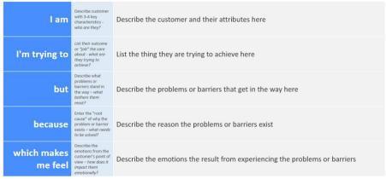

**Reference**: https://miro.com/app/board/uXjVK2aqlmY=/?share_link_id=534024970903

**Example:**

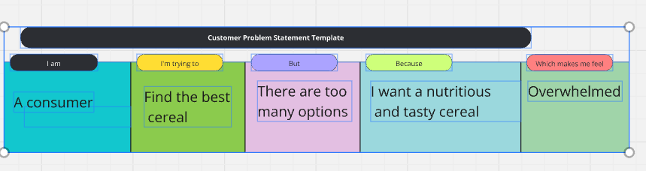

| **Problem**  **Statement (PS)** | **I am**  **(Customer)** | **I’m trying to** | **But** | **Because** | **Which makes me feel** |
| --- | --- | --- | --- | --- | --- |
| PS-1 | A nutritionist | Recommend healthy cereals | Nutritional information is confusing | I need to provide accurate advice | Frustrated |
| PS-2 | A parent | Choose a cereal my kids will eat | My kids are picky | I want them to have a balanced diet | I want them to have a balanced diet |